Andre Hardy – Project 5-4

I could not get a free scan with Norton, however, I was able to complete the scan using AVG instead.

8. After the app has loaded and scanned, click through the various options for this app. Would you consider this antivirus app one that you would use on your Android device?
A: Yes, I would use the paid features on my mobile device.
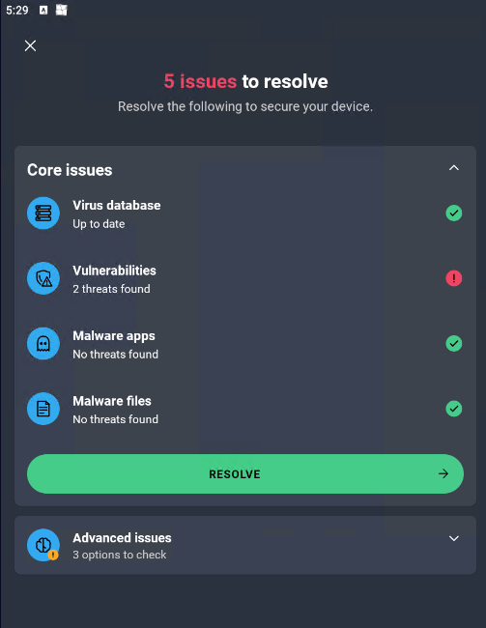

18. How easy were these apps to install and configure? How do they compare with comparable desktop antimalware apps?
A: Installing and configuring these apps were similarly simple as installing and deploying on a desktop device.

